Unit 3, lesson 3: Brain Fitness

Instructions:
- Complete this lesson in digital, in your copybook or print the worksheet.
- Once you finish, go to classroom and upload evidence of your work.
- Then, complete the self-evaluation of the lesson published in classroom.

Any doubt, you can write to my email at nicolas.puga@colegiostmf.cl

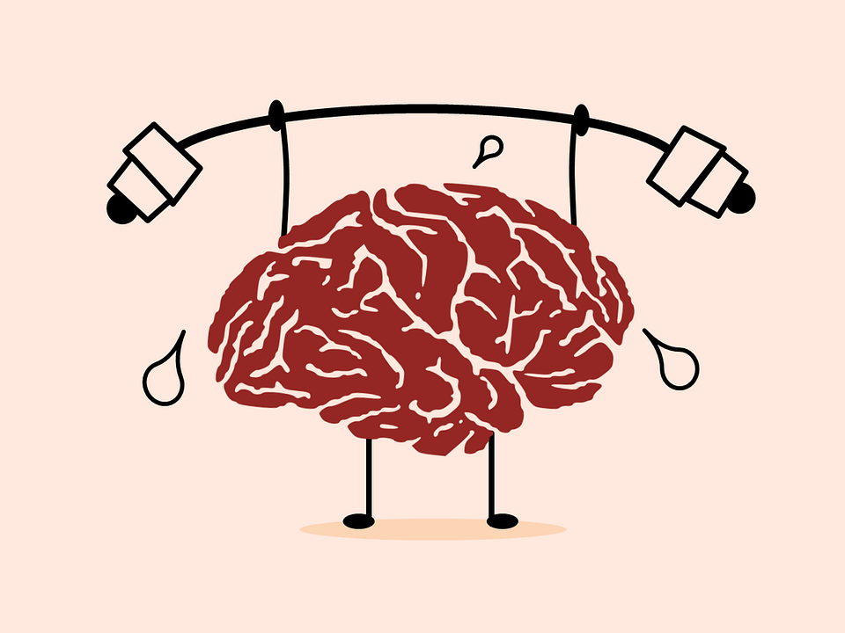

- Check (✓) the true statements about our previous class:
  - We read the multiple benefits of physical activity
  - We listened an audio about the dangers of doing too much physical activities
  - We listened an audio to complete the sentences with the correct alternative
  - We practiced English pronunciation
  - We produced a paragraph as final activity

- Check your answers from our previous class:
  - Exercise 4: identify the sports in the picture:

    - Sport a: weightlifting
    - Sport b: soreness
    - Sport c: bodyweight
    - Sport d: squats
    - Sport e: freediving
    - Sport f: mindfulness

  - What kind of audio? It’s a radio program because you can hear the music behind
  - Which two pictures best represent the audio? A-B // C-D // E-F
  - Complete the sentences with the correct option:
    - Some people feel intimidated by HIT
    - HIT and yoga improve your strength and endurance
    - Yoga helps with muscle tightness
    - Practicing yoga complements freediving traning
    - HIT, cycling and diving are fitness practice examples
  - After listening: meaning of the phrases
    - Going on a diet: comenzar una dieta
    - Keeping fit: mantener un buene estado físico
    - Gaining weight: aumentar de peso
    - In bad shape: tener un mal estado físico
  - Practice speaking and production: General feedback.

Today’s Lesson: we are going to prepare our brains to listen to English, learn something about the concept of brain fitness, practice with adverbs and pronunciation of keywords.

- Look at the pictures and describe what you see (number of people and activities)
  - What is the relationship between the pictures and the concept “healthy mind”?
  - Using the chat or the microphone, describe the concept of “mind fitness”.
  - What aspects of our lives can affect possitively or negatively in our mental health?

- Discuss: how does aging affect our brains? (memory and thinking).

- Listen to some facts about our brains. Choose the 5 most interesting for you. (Track 34)
  - Fact #1:
  - Fact #2:
  - Fact #3:
  - Fact #4:
  - Fact #5:

- Listen to more facts about the brain, complete the sentence with the words you hear. (Track 35)
  - Brain fitness has…
  - Focus on fish oils from wild …
  - Stories are a way to solidify …
  - … exercise is a great “brain exercise” too.
  - To really help your brain stay young …

- Listen again (track 35) and answer the questions about the recording:
  - How often is it necessary to meditate to increase your brain fitness?
  - What kind of fat should you eliminate from your diet?
  - What are the shortcomings of watching TV too long?
  - How learning skills improve your brain fitness?

- Grammar in-a-nutshell: adverbs
  - Read the sentences and pay attention to the words in bold. What do they convey?
    - Frankly, I don’t think I spend too many hours in front of the TV
    - Meditating has surprisingly helped me to develop concentration
    - The first thing we eliminated from our diet was trans fats, clearly.
      - The words convey manner
      - The words convey attitude
      - The words convey focus on specific information

The Adverbs from the example convey attitude because the subject has no relationship with the action.
- Attitude: clearly, it was a matter of time to see her change her diet.
- Manner: now, she can clearly see the consequences of her bad habit.

Well Done!

