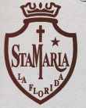
Colegio Santa María La Florida
English Department
Miss Xina Lebel
Time for school ( guía 1)
Name___________________________ grade: 2nd __________ Date: _______________
bin (basurero) - bookcase (estante) - board ( pizarra) - computer (computador)
cupboard (armario) - door ( puerta) - plant (planta) - teacher (profesor) - window (ventana)

Look and write the words ( Lee, observa y escribe las palabras)
Visita You tube: " school thinks song"
" school supplies song"

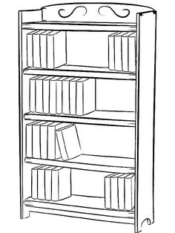
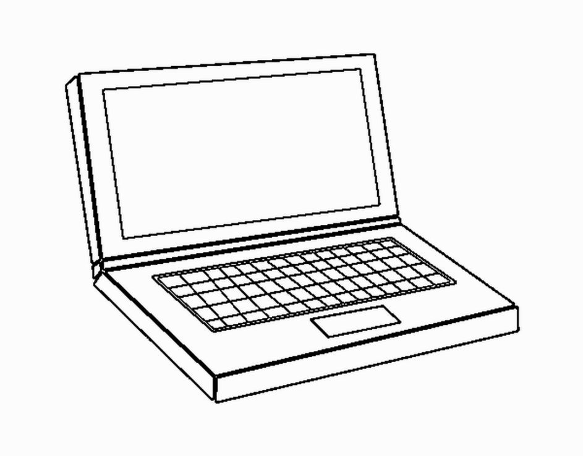

______________ _______________ ________________

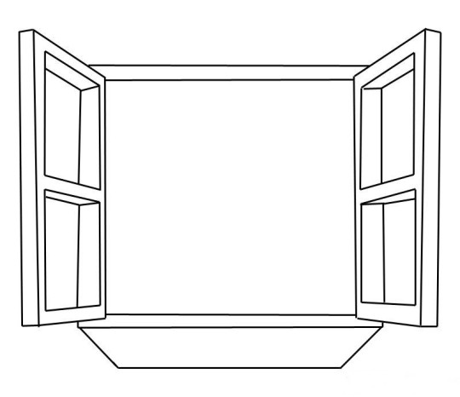
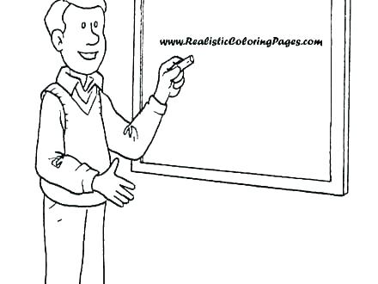

_______________ _______________ _________________

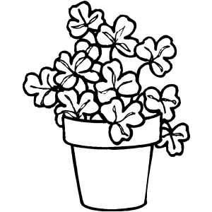
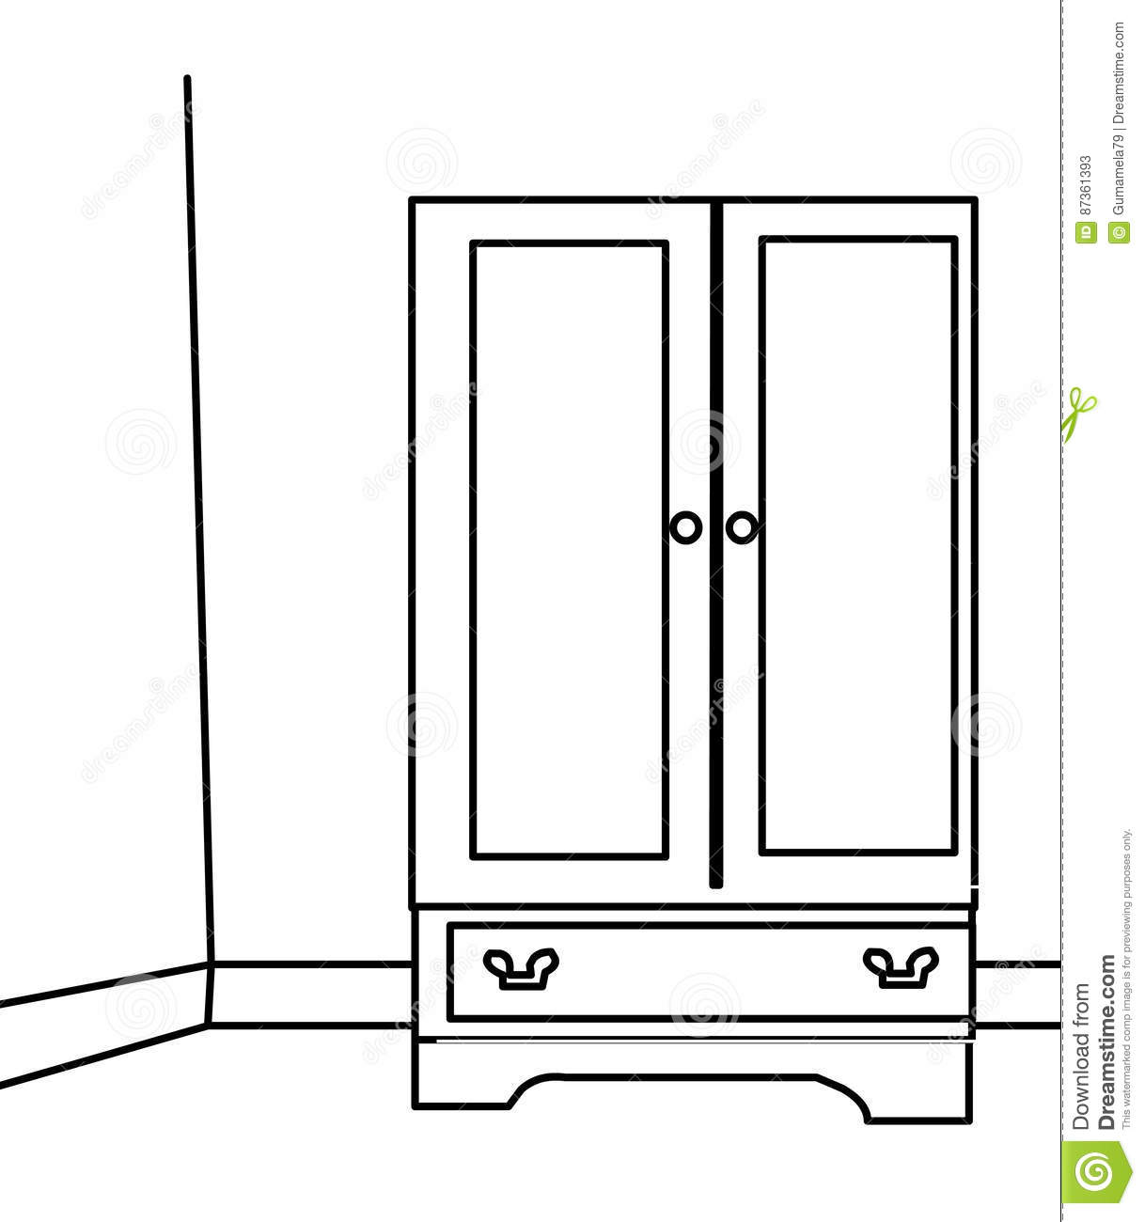
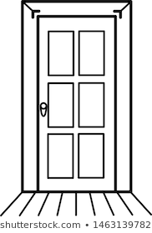

______________ _______________ ________________

See you!

